iSAM
Input File Specif

DRAFT

Author:
Scott Rasmussen
Zaita Design
scott.rasmussen@zaita.com

Table of Contents
Document History 3
CASAL II Overview 3
Supported Software Requirements 3
Development Environment 4
Operating Systems 4
Development Environment 4
Windows 4
Linux 4
Both 4
Coding Style 4
High-Level Design 5
Level 0 Data-Flow-Diagram 5
State-Transition Diagram 5
Software Components 6
Utilities Library 6
Configuration File Parser 6
Equation Parser 6
Minimisers 6
State-Model 6
Plugin Architecture 7
Dynamic-Library 7
Command-Line Executable 7
Equation Parser 7
OpenCL Kernel 8

Document History
Version | Description | Author | Date
1.0 | Initial version - Draft | S.Rasmussen | 20/11/2012

File Format Overview
The file format used for iSAM is based on the formats used for CASAL and SPM. It's a standard text file that contains definitions organised into blocks.
Example:
@block1 label
parameter value
parameter value_1 value 2

@block2 label
parameter value
table table_name
column_1 column_2
data_1 data_2
data_3 data_4
end_table

Some general notes about writing configuration files:
- 1. Whitespace can be used freely. Tabs and spaces are both accepted
- 2. A block ends only at the beginning of a new block
- You can include another configuration file from anywhere

Keywords And Reserved Characters
In order to allow efficient creation of input files iSAM's file format contains special keywords and characters that cannot be used for labels etc.

'@' Block Definitions
Every new block in the configuration file must start with a block definition character. The reserved character for this is the '@' character.
Example:
@block1 <label>
type <type>

@block2 <label>
type <type>

'Type' Keyword
The 'type' keyword is used for declaring the sub-type of a defined block. It must be defined on the line following the block command.
Example:
@block1 <label>
type <sub_type>

@block2 <label>
type <sub_type>

# (Single-Line Comment)
Comments are supported in the configuration file in either single-line (to end-of-line) or multi-line
Example:
@block <label>
type <sub_type> #Descriptive comment
#parameter <value_1> – This whole line is commented out
parameter <value_1> #<value_2>(value_2 is commented out)

{ } (Multi-Line Comment)
Multiple line comments are supported by surrounding the comments in { and }
Example:
@block <label>
type <sub_type>
parameter <value_1>
parameter <value_1> <value_2>

{ Do not load this process
@block <label>
type <sub_type>
parameter <value_1>
parameter <value_1> <value_2>
}

'-' (Range Specifier)
The range specifier allows you to specify a range of values at once instead of having to input them manually.
Example:
@process my_recruitment_process
type constant_recruitment
years_to_run 1999-2009 #With range specifier

@process my_mortality_process
type natural_mortality
years_to_run 2000 2001 2002 2003 2004 2005 2006 2007 #Without range specifier

',' (List Specifier)
When a parameter supports multiple values in a single entry you can use the list specifier to supply multiple values as a single parameter.
Example:
@process my_recruitment_process
type constant_recruitment
years 1999,2001,2003 # List specifier being used

'Table' and 'End_Table' Keyword
The table keyword is used to define a table of information used as a parameter. The line following the table declaration must contain a list of columns to be used.
Following lines are rows of the table. Each row must have the same number of values as the number of columns specified.
The table definition must end with the 'end_table' keyword on it's own line.
Example:
@block <label>
type <sub_type>
parameter <value_1>
table <table_label>
<column_1> <column_2> <column_n>
<row1_value1> <row1_value2> <row1_valueN>
<row2_value1> <row2_value2> <row2_valueN>
end_table

Block Definitions

Model
The model definition is the top level definition and contains specific information regarding the overall structure and performance of the model.
An example definition of a model has been supplied and descriptions of the parameters provided below.
Example:
@model
years <start_year> <final_year>
lengths <min_length> <max_length>
length_plus <value>
ages <min_age> <max_age>
age_plus <value>
initialisation_phases <value_1> <value_n>
time_steps <value_1> <value_n>

Years
Description: The year parameter defines the ranges of years for the model to run. So the model will run from <start_year> to <end_year> both inclusive.
Parameter 1: Unsigned. The start year, or initial year for the model.
Parameter 2: Unsigned. The final year for the model.

Lengths
Description: The lengths parameter defines the ranges of lengths supported in this model. While not necessary as you can define the lengths for each category individually this allows a verification check to be done across the model at a global level.
Any categories that attempt to be defined with a range of lengths outside the model range will fail verification.
Parameter 1: Unsigned. The shortest length supported by the model
Parameter 2: Unsigned. The longest length supported by the model

Lengths_Plus
Description: The length_plus flag determines if all categories will support any lengths above their max length being put into the max length value.
Parameter1: Boolean.

Ages
Description: The ages parameter defines the range of ages supported in this model. While not necessary as you can define the ages for each category individually this allows a verification check to be done across the model at a global level.

Any categories that attempt to be defined with a range of ages outside the model range will fail verification.
Parameter 1: The lowest age supported by the model
Parameter 2: The highest age supported by the model

Categories

The iSAM model is essentially a 2-dimensional model. The model partition is Categories*Ages/Lengths.

Each category supports the ability to have a different range of ages/lengths and accessibility during different time periods.

Because each category is quite complicated the syntax for defining categories has been structured to allow complex definitions using a simple short-hand structure.

Example:
@categories

type <sub_type>
parameter <value_1>
table <table_label>
<column_1> <column_2> <column_n>
<row1_value1> <row1_value2> <row1_valueN>
<row2_value1> <row2_value2> <row2_valueN>
end_table

Operating Systems

Microsoft Windows 7 (x64)
OpenSuSe 11.4 Celadon (x86_64)

Development Environment

Note: It is expected that during the development of CASAL II some of these tools/libraries will be upgraded to more current versions as they are released.

Windows
- TDM-GCC 4.6 (http://tdm-gcc.tdragon.net/ )
- Notepad++ (http://notepad-plus-plus.org/ )
- AQTime3 – Profiling
- AMD Code Analyst
- AMD App Profiler

Linux
- GCC/G++ 4.5.1
- Valgrind

Both
- Eclipse Indigo (http://www.eclipse.org/ )
- Boost 1.49.X (http://www.boost.org/ )
- CMake 2.8.X (http://www.cmake.org/ )
- CLANG (http://clang.llvm.org/ )
- GNU Debugger (GDB)

Coding Style

While it's going to be a step away from the style used for SPM, CASAL II will use the Google Coding style (http://google-styleguide.googlecode.com/svn/trunk/cppguide.xml ). Google provides a handy script to parse source code and highlight errors that do not match their coding style.

Spelling of variable names, classes etc will all be done using British English.

Note: The only deviation from this style is the use of *.cpp instead of *.cc for filename extensions.

High-Level Design

Level 0 Data-Flow-Diagram
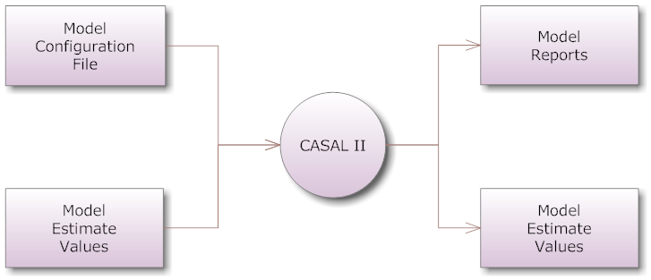

State-Transition Diagram
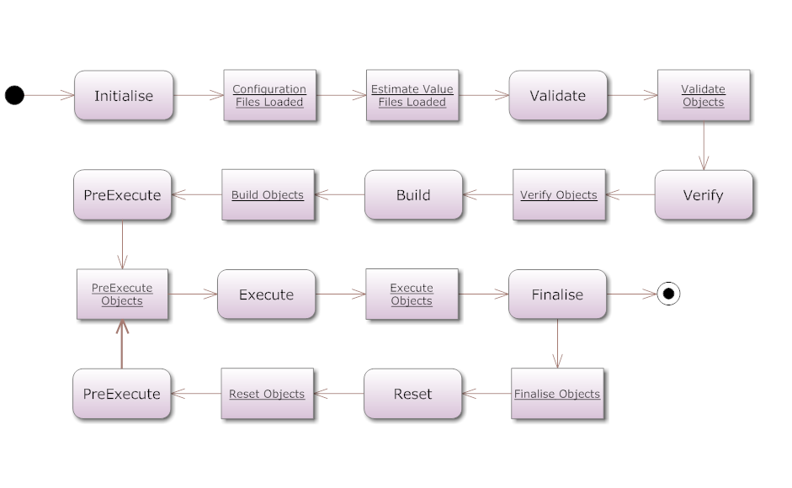

State Descriptions

Initialise
The initialise state is the creation of components and parsing of configuration files.
Tasks completed:
- Parse command line
- Parse configuration file
- Load plugins
- Load estimate values from input files

Validate
The validate state is used for checking user supplied options and parameters to ensure they fit within hard-limits imposed by the software.

Verify
The verification state is used to check the loaded configuration against logical business rules. These are not hard-conditions imposed by the system, but more logical conditions to ensure the user's configuration file is going to produce a logical and useful result.

The amount of verification done can be customised through the configuration file or command line options. This means verification is not forced, and can optionally be ignored.

Build
The build phase is where the system will build relationships between objects that rely on each other. Because validation has been completed, each object in it's self-contained configuration is ok.

This phase generally assigns values to shared_ptrs<> for objects so they don't need to do lookups of objects during execution phases.

PreExecute
The pre-execution phase is I don't know.

Execution
Das

Finalise
meh

Software Components

Utilities Library
A stand-alone library for doing common functions within NIWA's modelling applications will be developed for CASAL II.

This library will offer functionality like: Logging, Error handling, double comparison, vector/map manipulation, string manipulation.

Configuration File Parser
A stand-alone library for loading and parsing configuration files for NIWA's modelling applications will be developed for CASAL II. The code from this will be mostly inherited from SPM and Random Station, but will be largely re-factored to fit into a stand-alone library.

Equation Parser
CASAL II will use an open source equation parser with modifications to make it compatible with ADMB. It's likely that two equation parsers will exist within CASAL and a runtime decision will be made about which one to picked based on the runtime parameters.

Minimisers
CASAL II will support 3 minimisers natively,
- DE Solver
- GammaDiff
- ADMB

While ADMB does need tight integration with CASAL II, the other 2 minimisers do not. These minimisers will be extracted into seperate shared libraries and built as stand-alone components.

State-Model
As the state model for CASAL II is quite transferable across different modelling applications it will be also extracted into it's own stand-alone library.

Plugin Architecture

Dynamic-Library
Developers with enough competence in C++ will be able to develop and load their own plugins by building shared-libraries and specifying the location of these within their configuration files.

An expected inclusion section of someone's plugin would be:
#include <niwa/casal/process.h>
#include <niwa/casal/selecvity.h>

class myNewProcess : public niwa::casal::process {
public:
void validate() { }
void build() { }
void execute() { }
}

Difficulty for user to develop: High
Execution speed: Fast

Command-Line Executable
Some components of the application will be replacable with command line applications that take specific arguments and return a single result (e.g Selectivities/Layers).

A specification will be developed to allow people to build and specify stand-alone executable based plugins for specific functionality within CASAL II.

The upside to this approach is that the user can specify any type of executable they wish, developed in any language, including shell-scripts. The application will simply do an exec() call on that object and intepret the result.

Difficulty for user to develop: Low
Execution speed: Slow

Equation Parser
CASAL II will have an inbuilt equation parser for handling equations specified natively in the configuration file.

A valid example equation would be: 3^x * 2
Where the user is able to bind 'x' to an internal parameter inside CASAL II.

Difficulty for user to develop: Low
Execution speed: Slow

OpenCL Kernel
Note: This method was investigated, but at this point in time will not persued. Keeping this information in here as a possible future expansion of the software.

An OpenCL kernel is a small file containing a vectorised C++ snippet of code. When CASAL II starts it's able to load the kernel and compile it against either a GPU (when one is present) or a CPU.

The speed benefits from using OpenCL on a GPU can be enormous because of it's natively ability to work with multi-dimensional sets of data. Other benefits are the ability to send someone a code-snippet and have CASAL II compile it on the fly for execution, so platform indepdence is not an issue.

The major downsides to this approach are development architecture and difficulty. Developing an application around an OpenCL architecture either has to be very modular or completely ingrained in the application's structure. Difficulty in developing for OpenCL is very high, especially among people who are not familiar with C++ syntax or vector languages (e.g R/S+).

Difficulty for user to develop: High
Execution speed: Extremely Fast

